1. Login to your OCI
2. Go to your instance > Console Connection > Create Console Connection.
3. A screenshot of a computer

   AI-generated content may be incorrect.Upload your downloaded public key, if don’t have than generate new key pair and download it.
4. A screenshot of a computer

   AI-generated content may be incorrect.Wait till the connection is established and appears active.
5. The downloaded private key must be in .pem format.
6. A computer screen shot of a program

   AI-generated content may be incorrect.Now open windows powershell and move to the location where the .pem key is placed using cd command.
7. 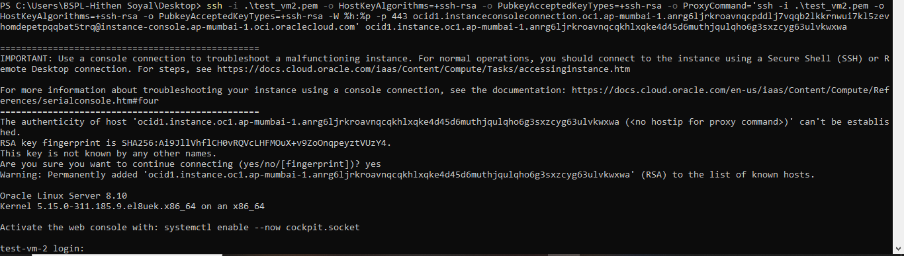Run the ssh command to establish the connection. (ssh -i oci_console_key.pem -o ProxyCommand="ssh -i oci_console_key.pem -W %h:%p -p 443 ocid1.instanceconsoleconnection.oc1.ap-mumbai-1.aaaa...@instance-console.ap-mumbai-1.oci.oraclecloud.com" ocid1.instance.oc1.ap-mumbai-1.aaaa...).
8. A black background with white text

   AI-generated content may be incorrect.Now login with your username and password.